Viking Invasions Map Exercise
Using an atlas, locate on your map the following important locations of the Viking Invasions on Europe from the ninth to twelfth centuries.
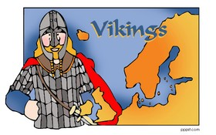
1. Shade in and label the homeland of the Vikings:
- Scandinavia: (in different shades of blue)
  - Norway
  - Sweden
  - Denmark
2. Shade and label in the following invaded European counties:
- Scotland - Red
- Ireland - Green
- Wales - Purple
- England - Pink
- France - Orange
- Germany - Yellow
- Netherlands - Red
- Belgium - Green
3. Star and label the following important cities
- Dublin, Ireland – the location of the first Viking permanent settlement
- Lindisfarne, England – the location of the first Vikings invasion
4. Using the map on the SMART board, draw in the arrows representing the Vikings raids by sea. (The Vikings routes are represented by the orange arrows)

When you are finished, hand it in!

