The HENRY G. Gazette

Date of Event | Place of Event |  | Your Names
What do I Need to Do?  You are the newspaper editor of a Middle Ages newspaper (the printing press was invented in 1440) and your task is to write an article for the front page of the newspaper.  Your newspaper MUST have the following:  _____ A title banner with the name of your paper,  the date, etc.  _____ One large article about an event from the  Vikings timeline. Base your article on facts  and add create elements.  _____ A picture with a caption (Can be hand  drawn or from the internet)  _____ Remember, newspapers are written in 3rd  person and answer the 5 W’s…  who, what, when, where, why |  | 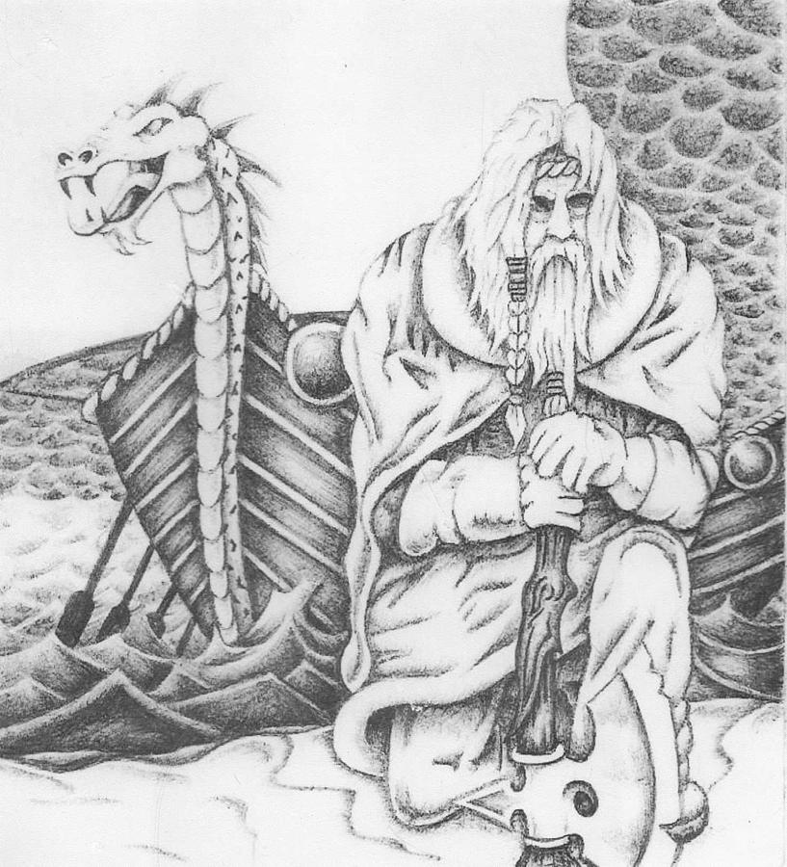  The Vikings arrive in London
Marking Criteria  Your article will be marked based on the following criteria:  Newspaper Elements:  /1  /1  /1  /1  /4  /4  /4  /4  /4  /1  /4  /4  /2  - Newspaper Title  - Article Headline  - Photo Caption  - Written in 3rd person  Content:  - Who?  - What?  - When?  - Where?  - Why?  Creativity  - Appropriate Photo  - In the written article  - Final product as a whole  - Newspaper and Article Headlines |  | To be handed in:  THIS Sheet  Brainstorming Sheet (1mark)  Final Article (with photo)
The Content aspects of your article will be marked on a 4 point scale:

4- Thorough and in depth
3- Good understanding
2- Basic Information
1- Minimal Information

 |  | TOTAL MARKS: / 36

