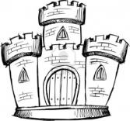
Day in the Life: Writing Piece
To be handed in:
Life in Medieval Europe Chart 1 (completion marks)
Life in Medieval Europe Chart 2(completion marks)
Day in the Life: Writing Piece
In your writing piece, choose either a king/queen, noble, knight, or peasant and write about their daily life. Use your Life in Medieval Europe Charts 1 and 2 to help you complete this assignment. Be sure to include a brief introduction of the setting (Medieval Times).
Points to include: Clothing, entertainment, food, routines, hopes and fears, and where you call home.
Writing Piece Rubric:
 | Met | Not Yet
1. Accurate Information
2. Brief Dark Ages introduction
3. Describes clothing
4. Describes entertainment
5. Describes food
6. Describes routes
7. Includes hopes and fears
8. Describes “home”

9. Brief Conclusion (summary)

