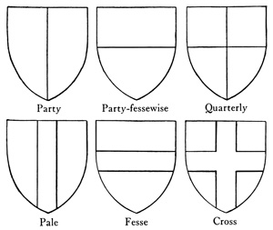
Knights: Coat of Arms
RUBRIC
To be handed in:
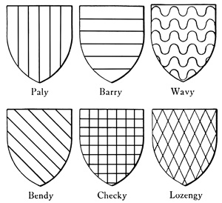
Brainstorming/Planning
Sketch
Final Coat of Arms
Write up
In your write up, describe your coat of arms. What does your coat of arms say about you? What does each piece represent?
Points to include may be: interests, values, family, friends, personality traits, where you live or are from, ect.
Your shield should contain ART ONLY that reveals who you are and what you stand for. The Mantle at the bottom of the shield must state your name as follows:
Boys: Sir____(First Name) of ______(Last Name)
Girls: Lady____(First Name) of ______(Last Name)
The way you color your coat of arms should also represent something about you.
 | Met | Not Yet
1. Explains the use of colour
2. Describes the use of at least 4 symbols
and their representation
3. Neat
4. Properly states name on mantle
5. Includes at least 4 symbols (art)
6. Coloured in
7. Ties in to medieval times (remember,
you are a knight in medieval times)
Write up examples:
Based on ________________________ I want to visually communicate that _______________________________.

I decided to draw ______________________________ to symbolize ______________________________________.

I used _________________________________________to hint that _______________________________________.
I used _________________________________________to represent ______________________________________.
It was important for me to ___________________________ because ________________________________________.
In order to show ____________________________________ I _________________________________________________.

