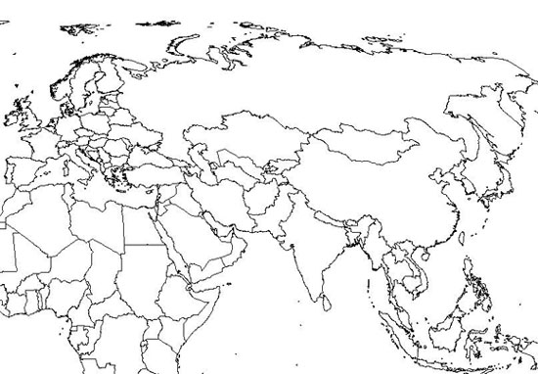
Mongol Empire Map Exercise:

- Lightly shade in, using any colour, the extent of the Mongol Empire at its peak (circa 1300)
- Label the following present day countries:
  - China
  - Mongolia
  - India
  - Japan
  - Iran
  - Saudi Arabia
- Name and label the largest country on Earth.

