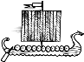
Middle Ages Newspaper – Brainstorming
Big Story Idea

What Happened??

Why Did it Happen??

Where Did it Happen??

Who Did it Happen To??

