Life in Medieval Europe
 | Clothing | Entertainment | Food | Lifestyle/  Daily Life
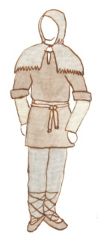
Peasant
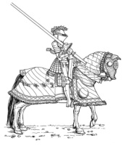
Knight
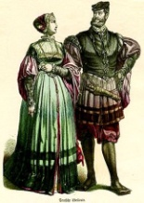
Noble
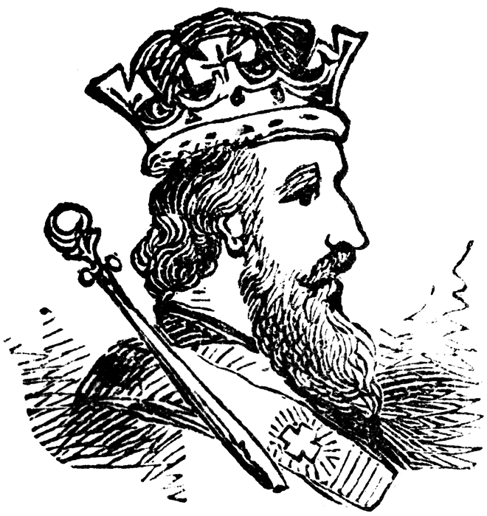
Monarchy

Life in Medieval Europe
 | Where did they live? | Hopes and Fears | Conclusion/ Summary
Peasant
Knight
Noble
Monarchy

