Knights: Coat of Arms
Imagine you're a knight in battle, you can't tell friend from foe, and then you realize your friends don't recognize you either. You need a new plan. This is it.
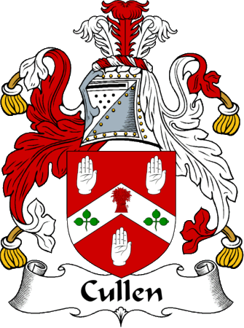
Coats of Arms date to the early Middle Ages. In the early twelfth century, helmets and other armor began making it difficult to tell armed warriors apart. The solution was for each knight or soldier to paint something personal on their shield. These designs were important in battle, but they also functioned like team uniforms when knights met in tournaments. Over time, shield emblem designs became enduring symbols of their owners, and of their owners' families.
It became quite fashionable to have a "coat of arms", so people hired artists to design them. The designs weren't just used on shields. They were applied on tunics, saddle blankets, banners and tapestries. They were duplicated in sculpture and architectural features. They were used in signs and advertisements. They were carved into coins, jewelry (e.g. signet rings) and the personalized stamps for sealing letters.
Soon, Coats of Arms weren't just for soldiers! From about 1210 A.D., some priests are known to have had them. The first women known to have had their own coat of arms got them around 1220. Around 1230 towns and cities began having coats of arms. Tradesmen and even peasants started using coats of arms around 1250. In an era when few people could read or write, coats of arms made it easier for people to recognize each other's marks.
Before you design your own coat of arms, it'll be useful to look at a few traditional heraldic designs. Observe the traditional design elements. What do you think they symbolized for the people who chose to wear them? Below is a list of some elements you may want to include in your designs.

The Language of Heraldry
Heraldic Colors:
Yellow or Gold - Generosity
White or Silver - Peace & Sincerity
Black - Constancy (& sometimes Grief)
Blue - Loyalty & Truthfulness
Red - Military Fortitude & Magnanimity
Green - Hope, Joy & sometimes Loyalty
Purple - Royal Majesty, Sovereignty & Justice
Heraldic Animals:
Bear - Protectiveness
Bee - Industriousness
Camel - Perseverance
Dog - Loyalty
Double Eagle & Eagle - Leadership & Decisiveness
Dragon - Defender of Treasure
Falcon or Hawk - Eagerness
Fox - Cleverness
Griffin (part eagle, part lion) - Bravery
Horse - Readiness to Serve
Lion - Courage
Pelican - Generosity & Devotion
Raven - Constancy
Snake - Ambition
Stag, Elk or Deer - Peace & Harmony
Tiger - Fierceness & Valor
Unicorn - Extreme courage
Wolf - Constant Vigilance
Heraldic Symbols:
Axe - Dutiful
Bridge - (signifies a governor or magistrate)
Crescent - Enlightenment
Crosses - Christian sentiments
Crown - Authority
Fire - Zeal
Flaming Heart - Passion
Fleur-de-lys (stylized Iris flower) - Purity (associated with France)
Hand - Faith, Sincerity & Justice
Heart - Sincerity
Horns & Antlers - Fortitude
Lightning - Decisiveness
Moon - Serenity
Oyster Shell - Traveler
Ring - Fidelity
Scepter - Justice
Star - Nobility
Sun - Glory
Sword - Warlike
Tower or Castle - Fortitude & Protectiveness
Common Design Features (heraldic terminology):
Bend - a diagonal stipe
Chevron - an upside-down "V"
Chief - broad stripe across top of shield
Dexter - the righthand side of the shield (from its user's perspective)
Ermine - a white fur pattern (with black tail tips)
Fess - broad horizontal stripe through center
Pale - broad vertical stripe through center
Passant - an animal shown walking
Rampant - an animal standing on hind legs
Sinister - the lefthand side of the shield (from its user's perspective)
Other important design details:
Besides simple fields of color, a coat of arms may contain other design motifs, such as checkerboards, polka dots, or fur patterns. One traditional design rule is that two solid-color fields shouldn't appear side by side unless one of the two is "metallic". Even this "rule" has been broken by many famous and historical coats of arms.
Few laws have ever been passed about the design of coats of arms, and even fewer of have ever been enforced! However, most European nations began requiring registration of coats of arms by the seventeenth century. The registration requirements were somewhat like modern trademark laws - they were primarily intended to stop people from copying each other's designs.

