Creating Your
Crusades Bitstrip
Steps of Instruction
- Follow the login instructions linked on my medieval times class site
- Create/ Edit your avatar
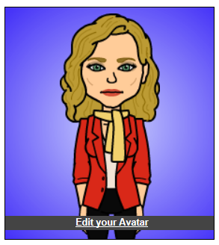
- Click on “My Comics” and then click “Make a Comic”
- Chose a layout for your comic. You can add additional frames to make up your total of six. Feel free to change your border color.
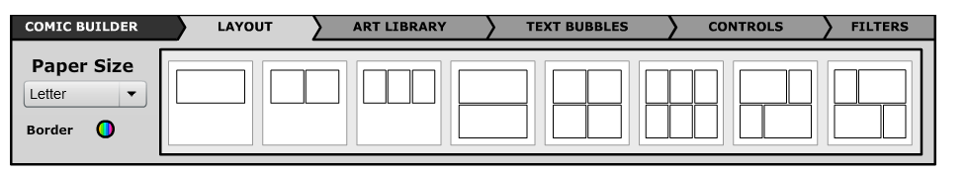
- Give your Bitstrip a title. i.e. The Crusades
- Move on to the Art Library tab, and create your bitstrip.
  - Familiarize yourself with each of the tabs
- Don’t forget to save your work at the bottom bar!

